**CSE5335: Web Data Management (Fall 2018)**

P**roject # 1.**

This assignment introduces each website scenario, presents the site map.

You have three tasks for this assignment

Task 1: Create a folder for the PetStore website called [yourlastname_petstore]

Task 2: Create the Home Page: index.html

Task 3: Create the AboutUs.html

Compress your folder and submit it.

**Do not email me the assignment.**

Due date: after finishing Chapter two

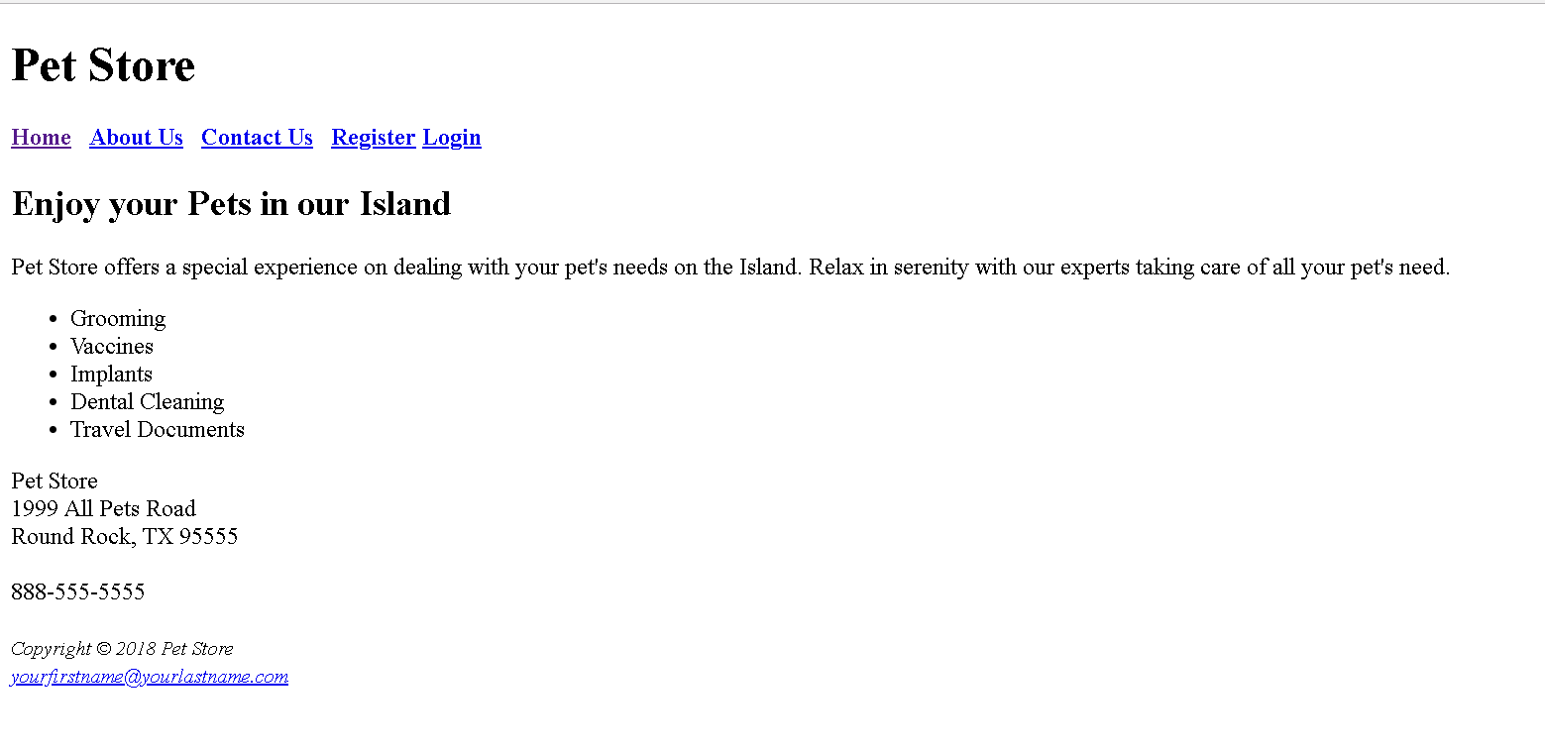

index.html

Aboutus.html

